Instructor: Dr. Mohd Salihan Ab Rahman
Students:
Asma Alkarbi (H00492811)
Hamdah Alkindi (H00492795)
Mariam Almessabi (H00492656)

Deliverable 1: Students habits & Academic performance
CDS: Data Visualization for Decision Making

Table of Contents
Case Overview 2
Stakeholder Analysis 2
Stakeholder Needs & Goals 3
Problem Statement 3
Use Case Description 3
Key Analytical Questions 4
Applications of Perception Principles 5
Design Constraints 6
Design Mockups 6
Design justification 9
Expected Impact 9

Case Overview
The goal of this dashboard project is to investigate how student habits, behaviors, and academic achievement are related. The dataset includes important behavioral variables such as daily study time, sleep duration, digital media usage, mental health rating, attendance, and exercise frequency.
The goal of this analysis is to understand how the lifestyle and behavior factors can influence exam results. Stakeholders, including academic advisors and school administrators, can determine which behaviors put students at risk for lower performance and which habits lead to improved academic achievement by visualizing these associations.
The dashboard offers a simple method for converting student behavior data into useful insights that aid in long-term educational improvement, intervention tactics, and academic preparation.

Stakeholder Analysis
The dashboard is structured to prioritize the data to make decisions and gain deeper insights on the correlation between student habits and academic outcomes. This is achieved by transforming student behavioral metrics into easily accessible summaries.
The Primary Stakeholders:
- School Administrators: often need high-level summaries to evaluate institutional policies, optimize resource allocation, and develop long-term educational plans.
- Academic advisors: use performance metrics to identify student groups that may require specific behavioral or academic interventions.
Secondary Stakeholders:
- Teachers & Education Analysts: These users examine the current trends to validate educational research.
Non-Target Users:
- Students: The dashboard it is not intended for individual student self-tracking or personal performance monitoring.

Stakeholder Needs & Goals
Stakeholder | Core Need | Dashboard Support & Analytical Alignment
Administrators | High-level insights for planning. | Pinpoints how digital media usage and habit combinations impact scores to guide strategic resource allocation.
Advisors | To detect risky behavior patterns | Analyzes the relationship between student habits and exam outcomes
Teachers & Education Analysts | Observe hidden correlations | Correlates study durations with performance to conduct further research

Problem Statement
There are other factors outside classroom instruction that affect students' academic achievement. Student outcomes are significantly influenced by variables like digital media intake, study habits, sleep quality, and mental health.
To assess how these behavioral patterns interact and impact exam performance, many educational institutions, however, lack transparent, data-driven methods. Decision-makers may find it difficult to determine which habits need assistance or intervention without the right visualization and analysis.
Thus, the necessity for an analytical dashboard that assists stakeholders in comprehending the relationship between student lifestyle choices and academic achievement so that well-informed initiatives to enhance student performance can be implemented is the issue this project attempts to address.

Use Case Description
Supporting educational decision makers in recognizing behavioral patterns that impact academic attainment is the dashboard's main use case.
The dashboard can be used by school administrators to assess how student behavior affects institutional performance and create rules that encourage more productive and healthy routines.
By examining the links that have been visualized, academic advisers can identify students who might be at risk because of inadequate sleep, low mental health scores, or excessive use of digital media, enabling early intervention. Also, advisors can make decisions about mental health wellbeing promotion through events and inviting professionals to educate students.
To improve exam results, teachers and education analysts can identify the best balance between study time and wellness aspects and evaluate trends in student behavior.
All things considered, the dashboard is a useful tool for decision-making that helps students understand how their lifestyle choices affect their academic achievement.

Key Analytical Questions
Some of the most important questions that can be answered through visualizing the data are questions that decision makers find helpful in identifying behaviors and patterns that impact the student performance. By data visualization, the stakeholders can locate specific factors contributing to academic performance. Decision makers can then determine strategic decisions to improve student performance. Questions include:
- How does study time per day influence exam performance? This question helps determine whether increased daily study time leads to higher exam scores. Understanding this relationship allows decision makers to know the best study durations and figure out if too much or too little study time has a negative impact on performance.
- What is the relationship between sleep duration and scores? Sleep is important for memory retention and cognitive function. This question looks at whether students who get proper sleep have a better academic performance, and this also helps promote healthy sleep habits as one of the academic success strategies.
- Do high digital media usage students perform worse? According to Fatmawati & Yusrizal (2025), excessive use of social media has been linked with impaired concentration which increases negligence in academia. This question explores whether higher digital media consumption is correlated with lower exam scores, and stakeholders can know what negatively impacts performance.
- How does mental health rating correlate with outcomes? Mental wellbeing directly affects concentration and motivation, which in turn impacts learning ability. In this question, stakeholders evaluate the mental state of students to see whether higher mental health ratings result in better academic results, and mental health awareness and support programs can be promoted to students.
- Which habit combinations characterize high performing students? Academic success is influenced by a combination of behaviors, and this question looks to identify patterns of habits that are common amongst high performing students. Things like sufficient sleep and balanced study time are amongst the strongest indicators of high achievers.

Applications of Perception Principles
Visual perception principles were applied to improve clarity and reduce cognitive load, allowing users to rapidly identify patterns related to academic performance.
Gestalt principles: they were used by grouping charts together to achieve proximity, which helped in faster pattern recognition and reduced search time. The summary table is placed at the center as the most important element. Chart designs are consistent and have one hue color to achieve similarity. Comparisons become easier across visuals.
Pre-attentive attributes: consistent color and clear chart positioning allow important insights to be picked up immediately. Scatter plots show clear relationships between scores and study time, sleep, and social media usage. The bar chart with its increase in color intensity representing the mental health shows that darker colors equate to higher performance.
Contrast and visual hierarchy emphasize important values, with darker bars representing higher scores and white spacing used to separate insights. This creates a clear visual hierarchy, helping the user's eyes see from the lowest to most important insights. A minimalist design with one message per chart and one hue color reduces clutter and supports fast interpretation for time constrained stakeholders.
Color accessibility: We chose to have a consistent blue all over with clearly different shades, avoiding multiple hues that could become confusing, and taking into consideration color blind individuals. Insights are communicated through positions and scale on top of color, to ensure that visualizations remain understandable.

Design Constraints
The design of the dashboard is influenced by the target stakeholders:
Fast Comprehension & Low Cognitive Load: Because primary stakeholders are time-constrained, the layout is designed for clear interpretation. ensuring users can grasp key insights immediately without being overwhelmed by data density.
Strategic Information Hierarchy: Key metrics are prioritized to provide immediate answers to core analytical questions, such as how study time per day influences exam performance.
Clarity: To maintain accessibility for non-technical professionals (since they are educators with no technical expertise), the dashboard avoids technical jargon and excessive statistical complexity.

Design Mockups

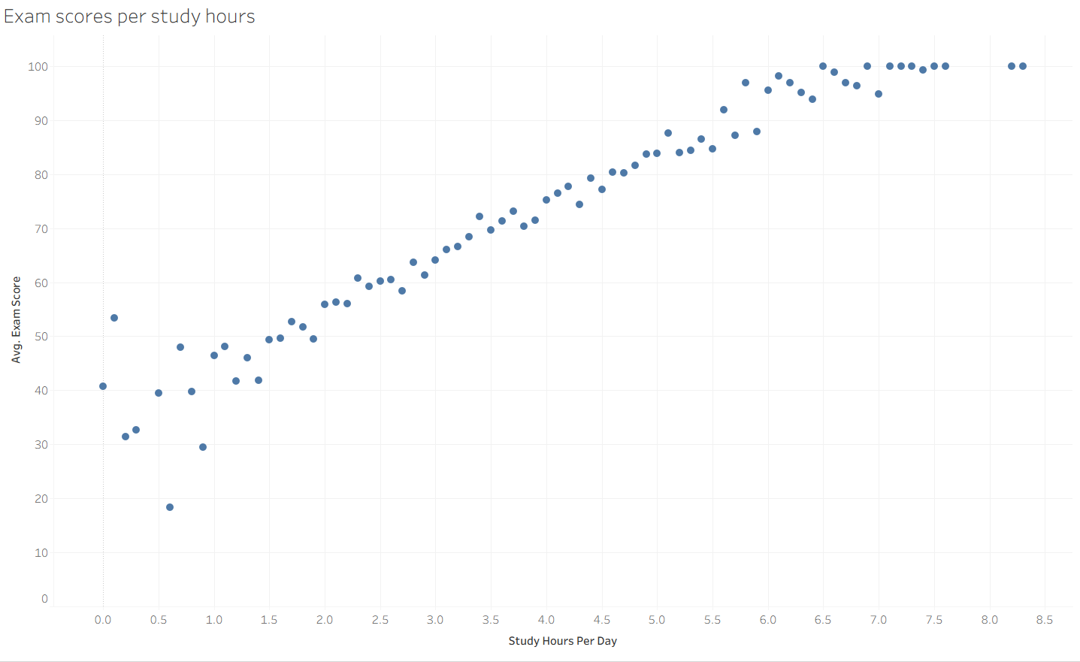
Proposed design 1: scatter plot for exam scores per study hours
Chart 1 – scatter plot: Exam scores per study hours: The scatter plot shows a clear positive relationship between study hours and exam scores. As daily study hours increase, so do the exam scores. This indicates that consistent studying is linked to academic success. The line stabilizes towards the end, showing that beyond a certain point, all scores are the same.
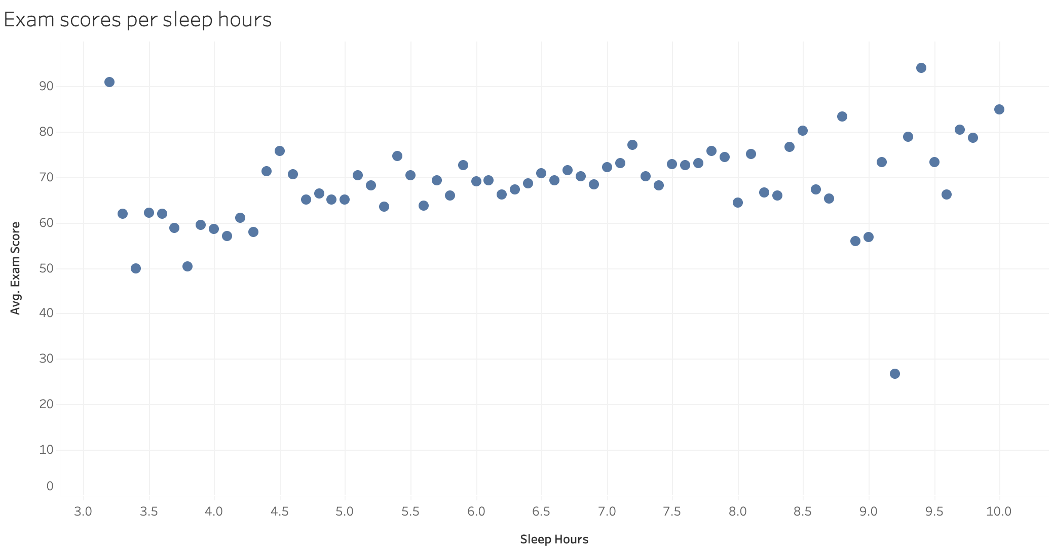
Proposed design 2: scatter plot for exam scores per sleep hours
Chart 2 – scatter plot: Exam scores per sleep hours: The scatter plot shows a slight positive relationship between sleep hours and exam scores. Lower sleep hours are generally associated with lower scores. Most higher scores appear when students sleep between 6 to 8 hours. There are some noticeable outliers where high sleep hours result in low marks and vice versa. This indicates that sleep is a prominent factor in academic success but not the only one.

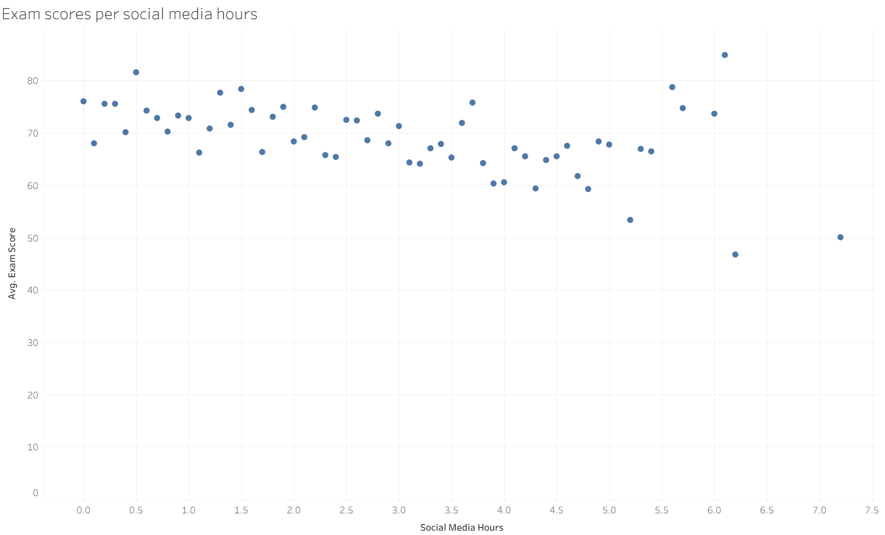
Proposed design 3: scatter plot for exam scores per social media hours
Chart 3 – scatter plot: Exam scores per social media hours: This scatter plot shows a weak negative relationship between social media usage and exam scores. As social media usage increases, exam scores generally decrease. Higher scores are more common at less levels of social media usage. At higher usage levels, scores become lower and more scattered. This suggests excessive social media usage may harm academic performance.

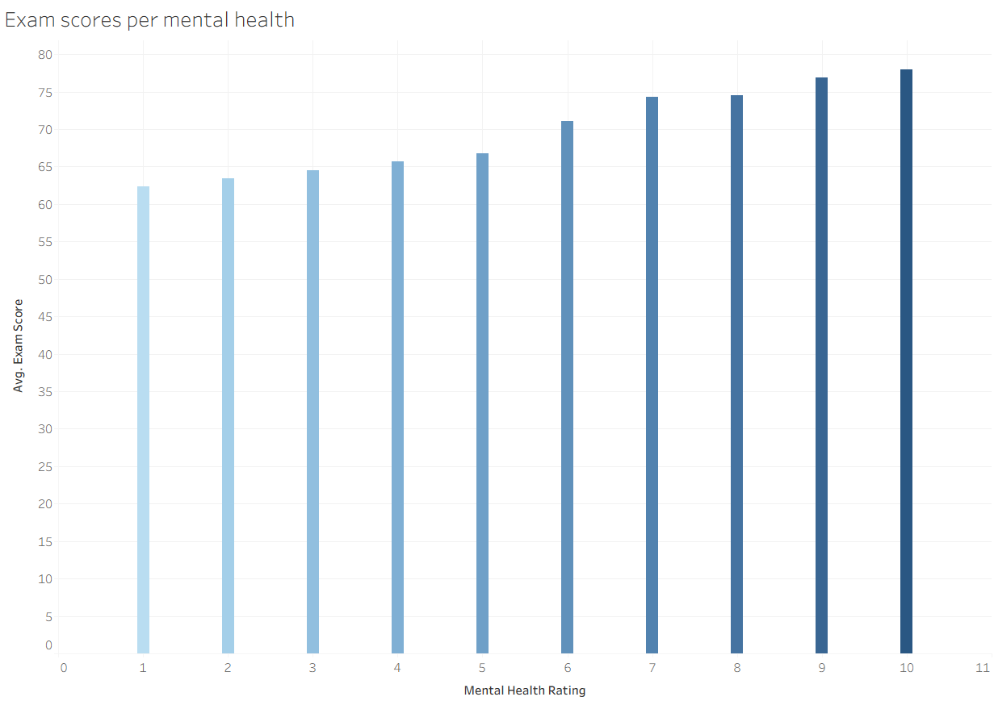
Proposed design 4: bar chart for exam scores per mental health score
Chart 4 – bar chart: Exam scores per mental health: This bar chart shows a range of scores from 1 to 10, with 1 being the lowest (and most negative) score and 10 being the highest (and most positive) score. There is a clear difference between students’ marks at a lower mental score versus students with a higher mental score. This chart shows how mental health strongly impacts academic performance.

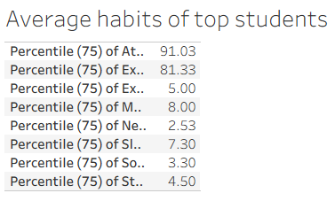
Proposed design 5: table showcasing average habits of top students
Chart 5 – table: Average habits of top students: This table only shows numbers associated with the 75 percentiles of students. These students have a very high attendance rate versus low social media usage. Their daily study time is reasonable though a tad bit excessive at 4.5 hours, but it pays off when combined with other factors such as sleep and exercise, showing that they don’t waste their lives away studying, rather also valuing their wellbeing which reflects in their average mental health score.

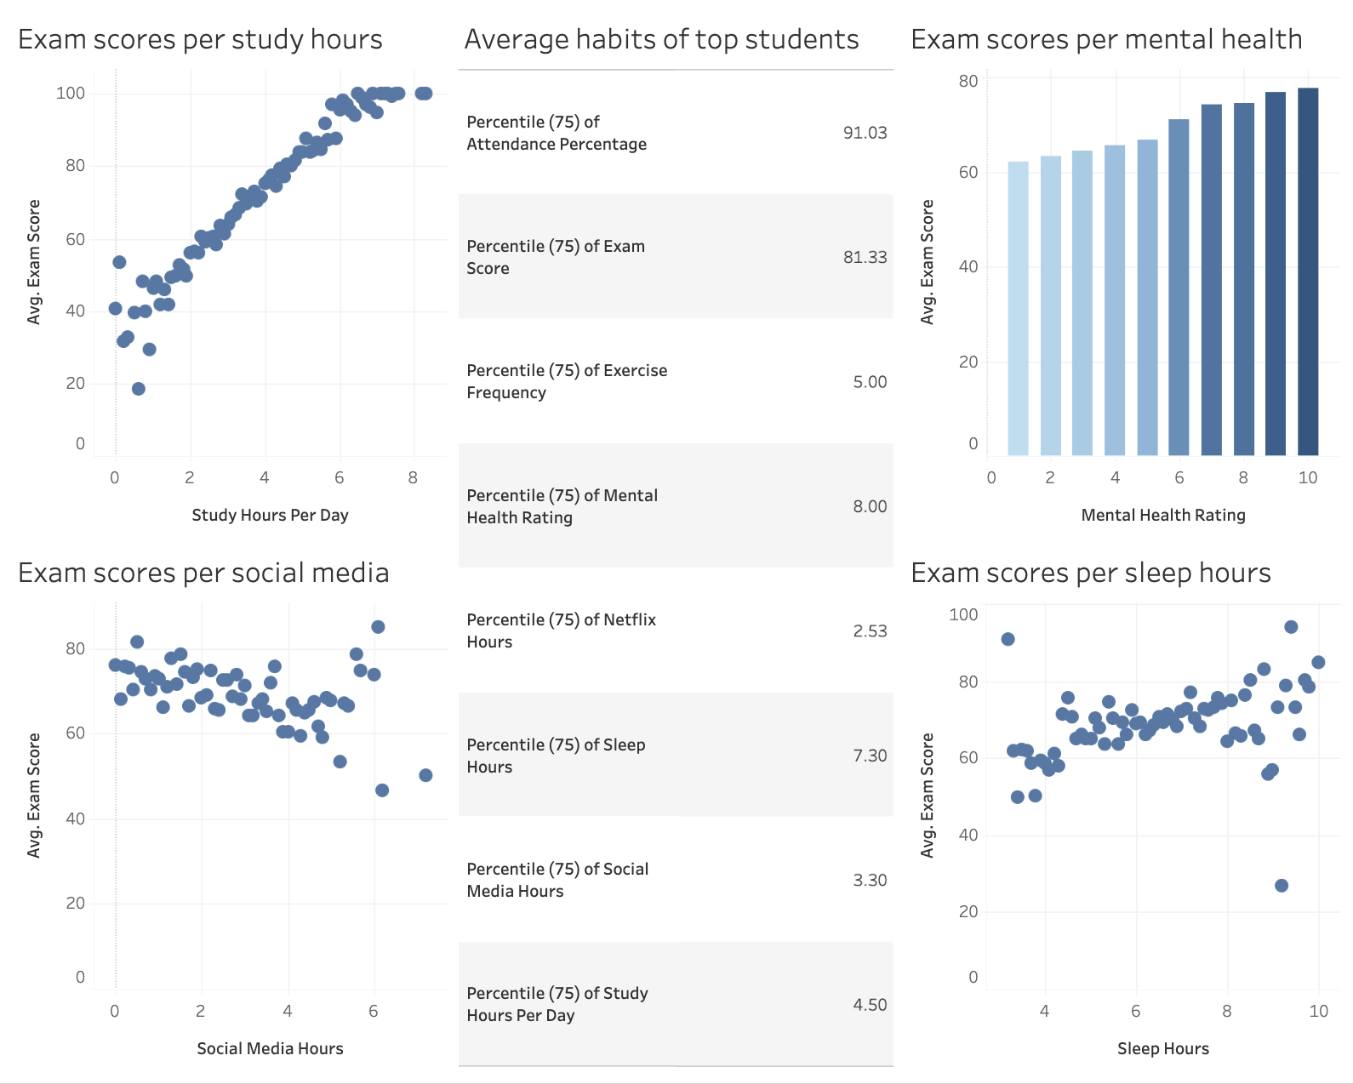
Dashboard combining proposed designs

Design justification: The dashboard emphasizes only meaningful data, allowing patterns to be identified quickly without visual distractions. Information is organized into 5 sections which align with short term memory limits, to support quick processing. The summary table is the largest element because it contains the most critical information for decision making. Color saturation in the bar chart shows stronger values. The theme is minimalistic with a single hue color to support consistency and reduce cognitive load, while also considering accessibility. Theres no decorative elements to minimize visual clutter and strategic use of white spacing in the table improves readability.

Expected Impact
The aim of making these visualizations is to support evidence-based academic decisions through carefully examining how daily habits can influence a student’s academic performance in both positive and negative ways. By doing so, administrators can conduct an early intervention for at-risk students which in turn increases student performance and successfully achieves set KPIs. This also helps promote healthier and more effective lifestyle and study habits to help students succeed in their academic journey.

References:
Fatmawati, F., & Yusrizal, Y. (2025). Literature Study: The Impact of Social Media on the Behavior of Grade IV Elementary School Students. In Proceedings of the 2nd International Conference on Education, Science Technology and Health (pp. 1122-1133).

